1. Write a C program to demonstrate character datatype.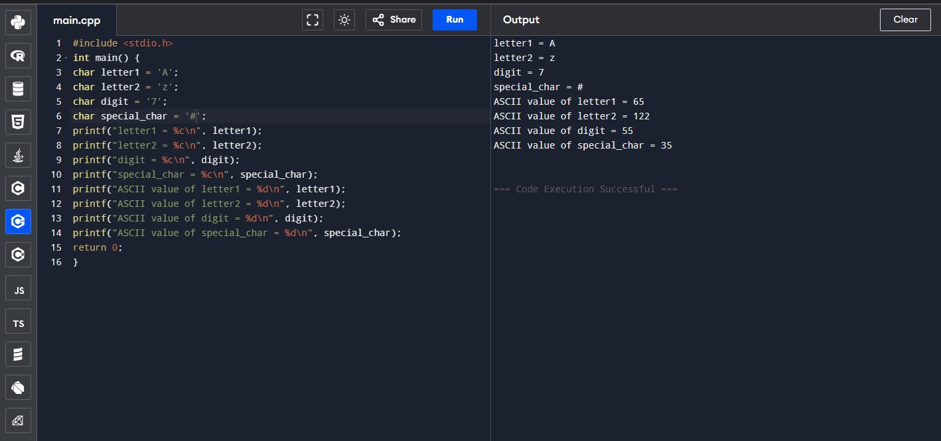
2. Write a C program to demonstrate float datatype for BMI calculation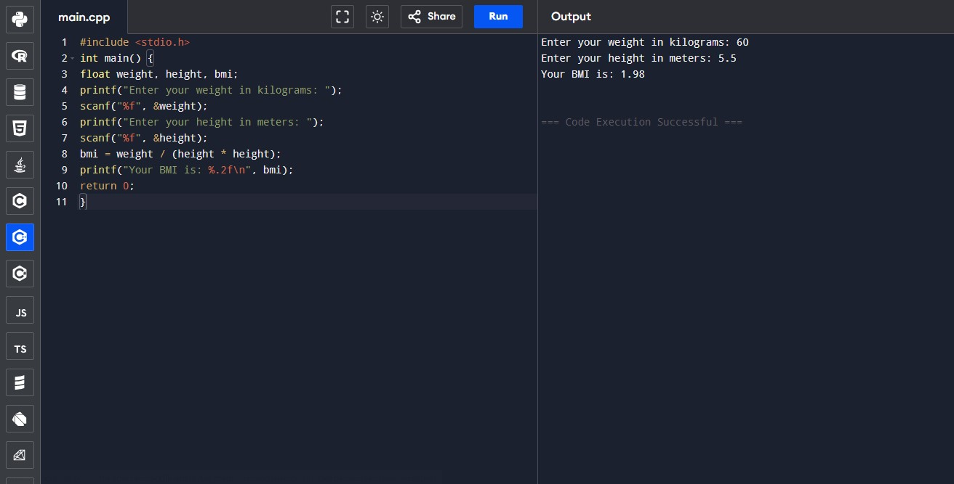
3. Write a C program to find the maximum of two numbers.

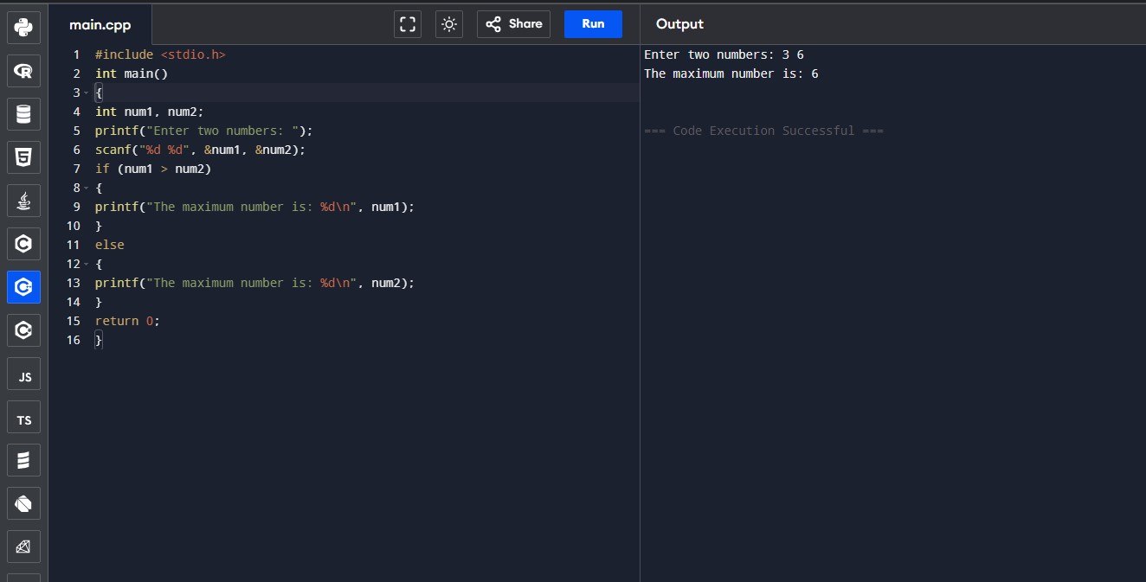
4.Write a C Program for voting eligibility check using Logical Operators.
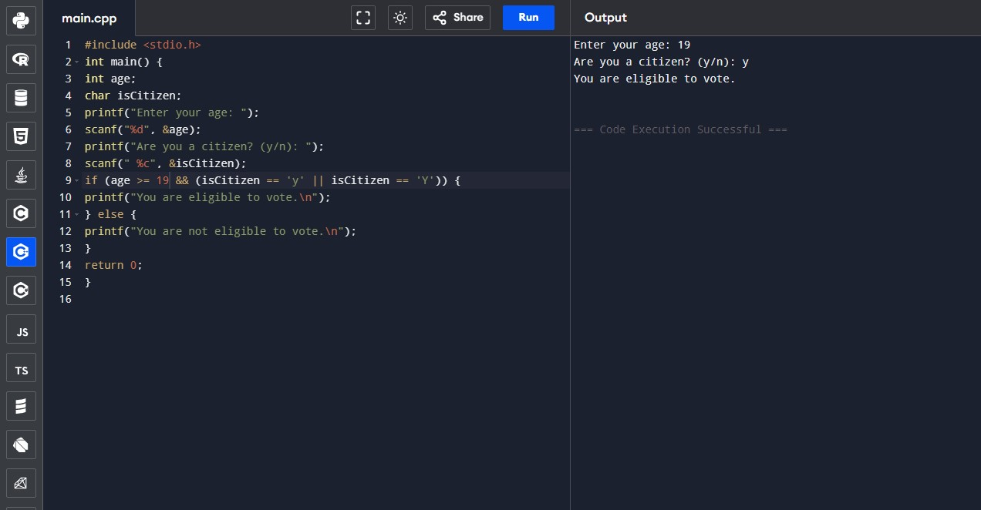
5. Write a C program to find the largest of three numbers. 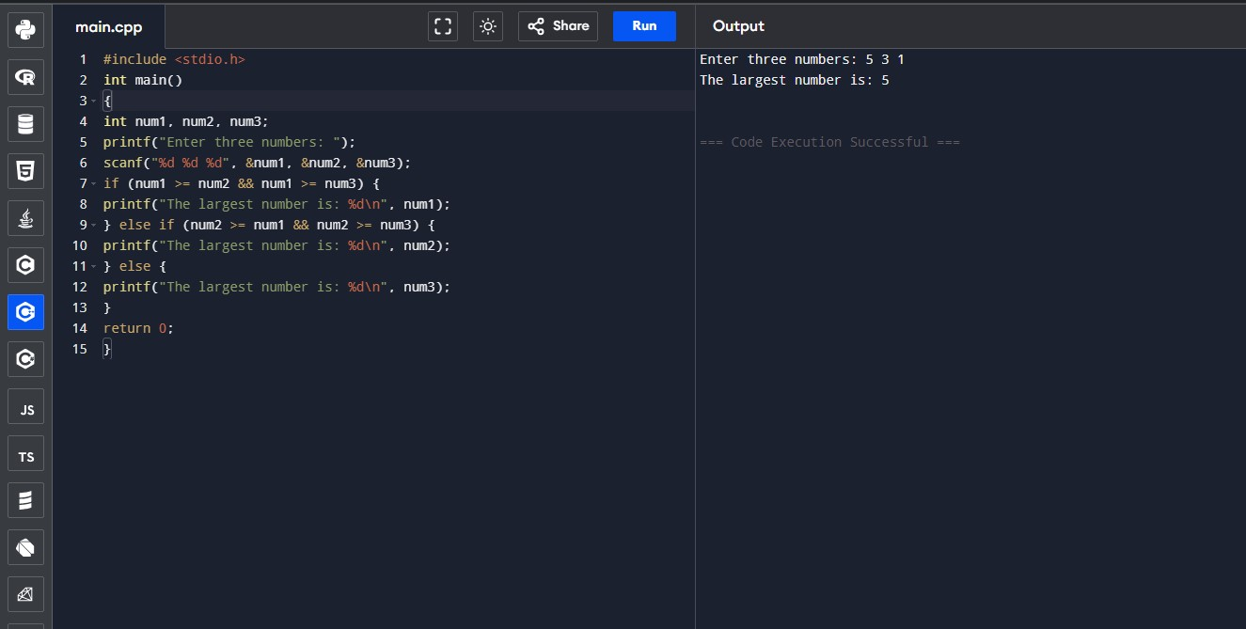
6. Write a C program that takes an integer as input and checks if it's a positive, negative, or zero using if-else statements.
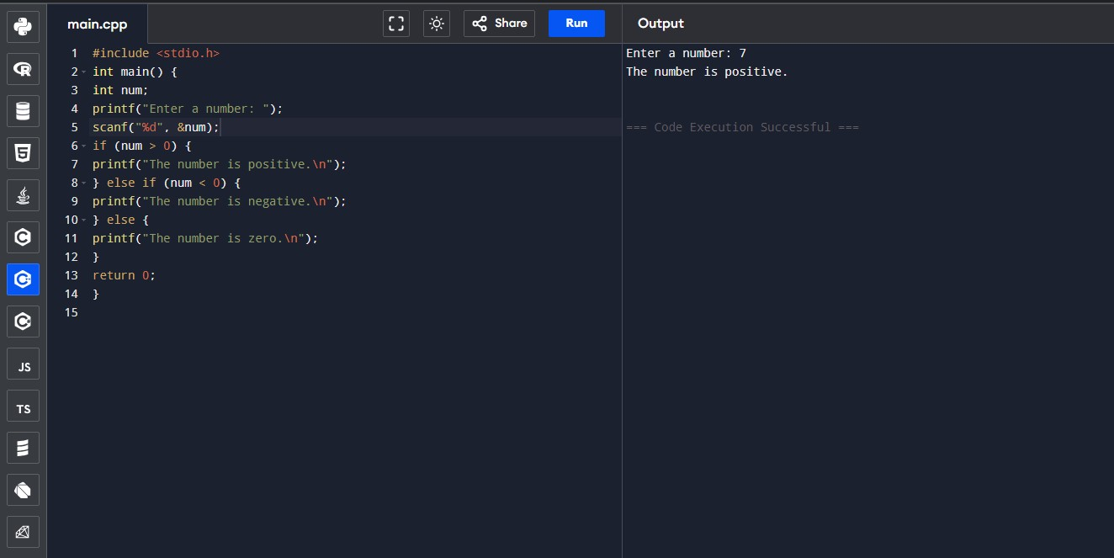
7. Create a C program that calculates the grade of a student based on their percentage score. Use if and else-if statements to assign grades (A, B, C, D, or F) according to the following criteria: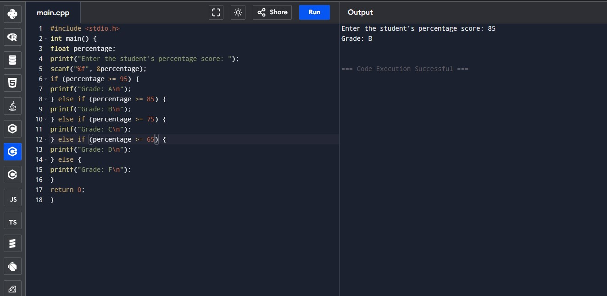
8. National Highway Department announces a scheme for the four wheeler in toll gate for 50 th year celebration. If the vehicle number is divisible by both 7 and 3 that will move on for free of cost. If the vehicle number id divisible by 2 and 8 then they should be pay half of the fee. Otherwise, you have to pay. Make sure the vehicle number doesn’t exceed 4 numbers

